**Evaluating the efficacy of common treatments used for *Nosema* control**

**Abstract**

**Introduction**

**Materials and Methods**

***Experiment 1: Laboratory Exposure to* Nosema ceranae *and Treatment with Fumagilin-B***®, ***Nozevit Plus®, and Honey-B-Healthy®***

In July 2014, capped combs were obtained from honey bee colonies at Oregon State University apiaries (Corvallis, OR, USA). We placed the combs in an incubator under simulated hive conditions (33° C, 55% RH) for bee emergence. Twenty four hours later we gently brushed newly emerged bees into a large container and mixed them thoroughly by hand. After the bees were mixed, we placed 250 individual bees inside cylindrical wire cages (63.06 cm3) and returned them to the incubator. The bees in cages were immediately provided with *ad libitum* access to a vial containing 25 ml of *Nosema ceranae* spores within 50% sucrose solution dosed at 40,000 spores/bee. Each cage also contained 25 g of finely ground wild flower pollen and mixed with a 33% sucrose solution in a 2:1 ratio.

The spore concentration of the *Nosema ceranae* solution was formulated and purified by centrifugation following the methods of Fries et al. (2013). Once the 25 ml solution containing *Nosema ceranae* was completely consumed, the cage was then provided *ad libitum* access to water and 50% sucrose syrup*.* Three days after the inoculation with *Nosema ceranae* spores, we provided 25 ml of treatment to the cages. There were 5 replicates per treatment which included Fumagilin-B®, Nozevit Plus®, Honey-B-Healthy®, and a control given only 50% sucrose syrup. We prepared all treatments according to the manufacturer’s recommendations. Once the 25 ml of treatment was completely consumed, cages were again given *ad libitum* access to water and syrup. In all, there were 4 treatments and 5 replicates (cages) of each treatment, for a total of 20 cages.

Once a week we measured consumption of the pollen and replaced them with fresh patties. Bee mortality was recorded every other day and dead bees were removed at time of diet replacement for convenience. We measured consumption of both water and sucrose solution and replaced them on alternate days. Sixteen and twenty-three days after spore inoculation, we removed 25 at random from each cage for infection analysis. The abdomens of the bees were used to estimate the *Nosema* prevalence and intensity as determined by the light microscopy techniques described by Cantwell (1970). Each bee abdomen was checked individually for *Nosema ceranae* infection. Prior to the experiment, wildflower pollen was sent for pesticide analysis to assess the possible presence of pesticide residues and DNA analysis was performed using the methods of Hamiduzzaman et al. (2010) to confirm that only *Nosema ceranae* spores were used in the inoculum.

***Experiment 2: Field Treatment using Hive Alive***® ***and Fumagilin-B***®

***Experiment 3 and 4: Winter Field Treatment using Fumagilin-B***® ***and Nosevit***® ***at Fall and Spring Recommended Treatments***

In January 2009 and December 2009 for experiment 3 and 4, respectively, honey bee colonies from the XX location in XX, Florida and the Straughn Blueberry farm located in Windsor, Florida, were assessed for the presence of *Nosema* infection.

*Colony Selection*

In experiment 3, colonies were first randomly assigned to treatment groups, we then sampled for *Nosema* infection. The intensity of *Nosema* were not significantly different at the beginning of the experiment between treatments. In experiment 4, we chose colonies that showed a mild to moderate *Nosema* infection of approximately 50,000 to 500,000 spores per bee (Ellis, J.D., personal communication) as candidates for the study. Of these positively infected candidates, 50 queen-right colonies of similar colony strength were selected and divided into the five treatment groups. All hives were equalized for honey within the supers. Each plot of 10 hives was located in an open sunny field on the blueberry farm and placed on wooden pallets, approximately 50 feet apart.

Nosema *Treatments and Experimental Design*

Control treatment groups received only sugar syrup at each of the applications. We used two treatments for each of the products, Nosevit® (Dadant & Sons, Hamilton IL) and Fumagilin-B® (Medivet Pharmaceuticals Ltd., Alberta Canada). We mixed dosages at label recommendations from both products, and made applications 2 (equivalent to “spring” treatment) and 4 (equivalent to “fall” treatment) times, 7 days apart from each other. The 2 applications (“spring” treatment) were followed by 2 feedings of only sugar syrup when the “fall” received its third and fourth treatment. In total, we used 5 treatments in each experiment: a control, “spring” treatments (2 applications) of Nozevit® and Fumagilin-B®, and “fall” treatments (4 applications) of Nozevit® and Fumagilin-B®.

*Sampling for* Nosema *infection*

For each sample of bees for *Nosema* assessment, we collected 100 bees per hive and placed them in 100ml containers with 70% ethanol and returned them to the laboratory. We removed the abdomens of 100 bees per sample and combined with one milliliter of distilled water per bee. We placed the solution into a sterilized Cooks Power Blender (JC Penny, Manchester, CT) and blended for 30 seconds until an even suspension was formed. For the preparation, we placed a drop of the resulting suspension onto a Hemacytometer (Hausser Scientific, Horsham, PA) and covering with a glass cover slip. We examined the resulting preparation under a compound microscope (Fischer Scientific Stereomaster) using x400 magnification. Using the 5-square method reported by Cantwell (1970), we calculated the number of spores per bee for each sample. In experiment 3, we sampled at the baseline of *Nosema* one week after the second treatment of all colonies, then one week after the fourth treatment of applicable colonies, and finally, 3 weeks later. In experiment 4, we again sampled *Nosema* at a baseline, followed by one week post treatment, then 2 weeks post, and the final sampling was 4 weeks after the initial treatment, each with N=10 colonies.

*Colony Assessment*

The colony assessors were unaware of treatment group assignments and had not visited the site during treatment application. In experiment 3, two observers estimated the area of each from covered by bees and brood at the end of the experiment, and the average estimation of the observers was calculated. In experiment 4, a baseline and final assessment were made by one assessor.

***Statistical Analyses***

Statistical analyses for all experiments were performed using R version 4.1.1. The effect of time was again analyzed as a factor in all analyses where applicable. In experiment 1, we used linear models (normal error structures) to test for relationships between the *Nosema* treatment and average consumption of pollen, water, and sucrose using the following model structure in the lme4 package (Bates et al. 2015): [response variable = treatment * time]. To compare survival across treatments, we used a log rank test in the survival package (Therneau, T. 2021). Bees that survived until the end of the experiment (Day 28) and those that were removed for *Nosema* intensity and prevalence were treated as censored cases.

For each response variable in experiments 2-4 (number of observed bees and brood from colony assessments, *Nosema* intensity, and number of *Varroa* per 100 bees), we analyzed the effect of the treatments (Experiment 2: Fumagillin-B®, Hive Alive®, and the control group; Experiments 3 and 4: Fumagillin-B® at fall and spring treatments, Nosevit at fall and spring treatments, and the control group) using linear models (normal error structure) for each response variable with the error structures: [response variable = treatment * time + colony (random effect)]. *Nosema* prevalence in all instances was analyzed using general linear models with binomial error structures and the same models as used above. Tukey’s honest significant difference (HSD) was used on the univariate models where multiple comparisons were made.

**Results**

***Experiment 1: Laboratory Exposure to Nosema ceranae and Treatment***

*Consumption of pollen, sucrose solution, and wate*r

On average, bees consumed 18.4 mL of syrup, 43.2 mL of water, and 3.9 g of pollen. The consumption of pollen was not significantly different between treatments (F3,233 = 0.09; *p* = 0.967). There were also no significant differences in sucrose syrup consumption between treatments (*F*3, 233 = 0.35; *p* = 0.791), or in the consumption of water (F3,233 = 0.48, p = 0.699). Trace amounts of several pesticides were found in the wild flower pollen (Appendix Table A.1).

*Nosema prevalence and intensity*

The Nozevit Plus® and Honey-B-Healthy® treatments both had an infection prevalence of 4.8% while the control and Fumagilin-B® treatments had an infection prevalence of 3.2% and 2.4%, respectively. The median *Nosema ceranae* infection intensity for Honey-B-Healthy® was 2.8 x 106 spores/bee,while Nozevit Plus®, the control and Fumagilin-B® treatments were 2.22 x 106, 1.83 x 106, and 1.13 x 106 spores/bee, respectively. The effect of time of sampling on *Nosema ceranae* prevalence was statistically significant (*χ2* = 6.79; *p* = 0.009), as was the prevalence of *Nosema* infection between the treatments (*χ2* = 11.80; *p* = 0.008), and the interaction between treatment and time of sampling was also significantly different (*χ2* = 13.23, *p* = 0.004). The intensity of *Nosema* infection was not significantly different between the treatments (*F*3, 34 = 0.66; *p* =0.586). Multiple comparisons are made in Table xx. There was a significant effect of time of sampling on *Nosema* intensity (F3,36 = 4.21, ­*p* = 0.049), but the interaction between treatment and time of sampling was insignificant (F3,36 = 1.06, *p* = 0.38).

*Survival analysis*

Kaplan-Meier survival curves were used to plot the survival data (Fig. 1) and log rank tests were used to compare the survival curves of the various treatments. Log rank tests indicated that there were significant differences in survival among bees that were fed with different ratios of pollen and cellulose (χ2 = 17.1; df = 3; *p* < 0.001). Kaplan-Meier curves showed that bees in the control treatment had the highest survival, followed by the Nozevit Plus® and Honey-B-Healthy® treatments. The Fumagilin-B® treatment had the lowest survival.

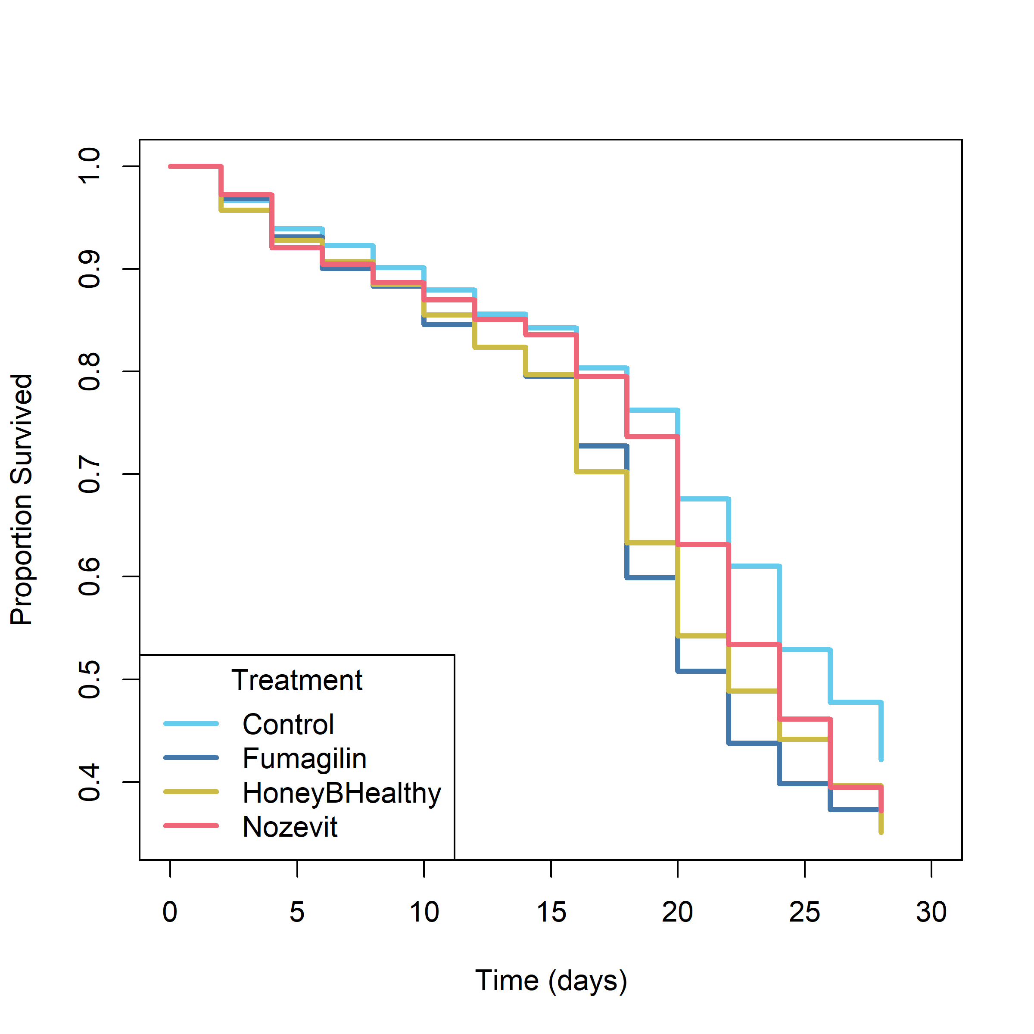

*Figure 1: Survival of bees fed* Nosema *and treated afterward in experiment 1.*

*Table: Experiment 1: prevalence of* Nosema *treatments at two sampling days. Letters represent significance to the 0.95 confidence level.*

|  |  |  |
| --- | --- | --- |
| Treatment | Sampling Day | Prevalence (%) |
| Control | 16 | 2.4 a |
| Fumagilin-B® | 16 | 2.4 a |
| **Honey-B-Healthy**® | **16** | **7.2 b** |
| Nozevit Plus® | 16 | 6.4 ab |
| Control | 23 | 4.0 ab |
| Fumagilin-B® | 23 | 2.4 a |
| Honey-B-Healthy® | 23 | 2.4 a |
| Nozevit Plus® | 23 | 3.2 ab |

***Experiment 2: Field Experiment – Hive Alive***® ***and Fumagilin-B***®

Overall, the number of *Varroa* per 100 bees across all treatments decreased over the course of the experiment, and the effect of time was significant (F4,439 = 12.44, *p* < 0.001). The interaction between treatment and time was not significant (F8,439 = 0.96, ­p = 0.469). Tukey’s HSD showed a significant decrease in *Varroa* per 100 bees in the Hive Alive® and Fumagilin-B® treatments during the second month (January) compared to controls (t = 2.51, *p* = 0.013).

Generally, *Nosema* intensity in bees increased over the course of the experiment, regardless of treatment then decreased in the final month of the experiment. There was a significant effect of the treatment on *Nosema* (F2,438 = 5.42, *p* < 0.005), time (F4,438 = 26.06, *p* < 0.001), and the interaction between treatment and time (F8,438 = 2.88, *p* < 0.004). Tukey’s HSD showed a significant increase in *Nosema* in April for the Fumagillin-B® treatment (t = 2.72, *p* < 0.006) and in April for the Hive Alive® treatment (t = 3.27, *p* = 0.001).

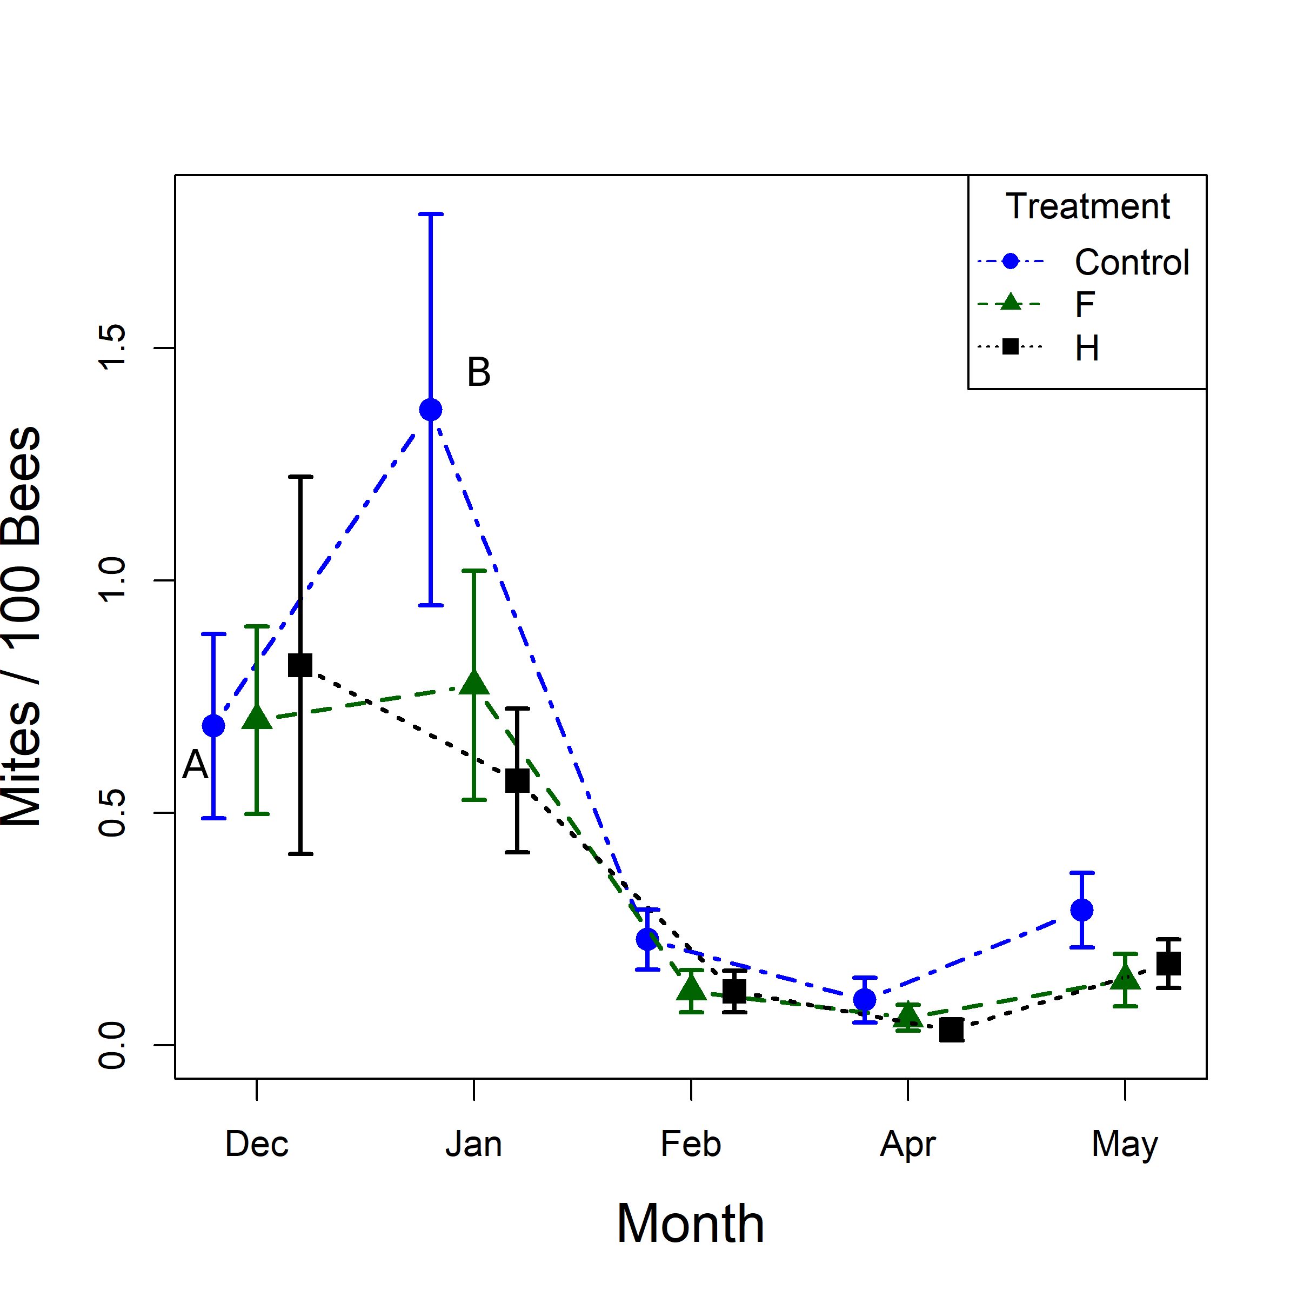

*Figure: Number of mites per 100 bees over time. Letters represent significance, only controls in January were significantly different from other averages. Will add information if we decide to use these graphs.*

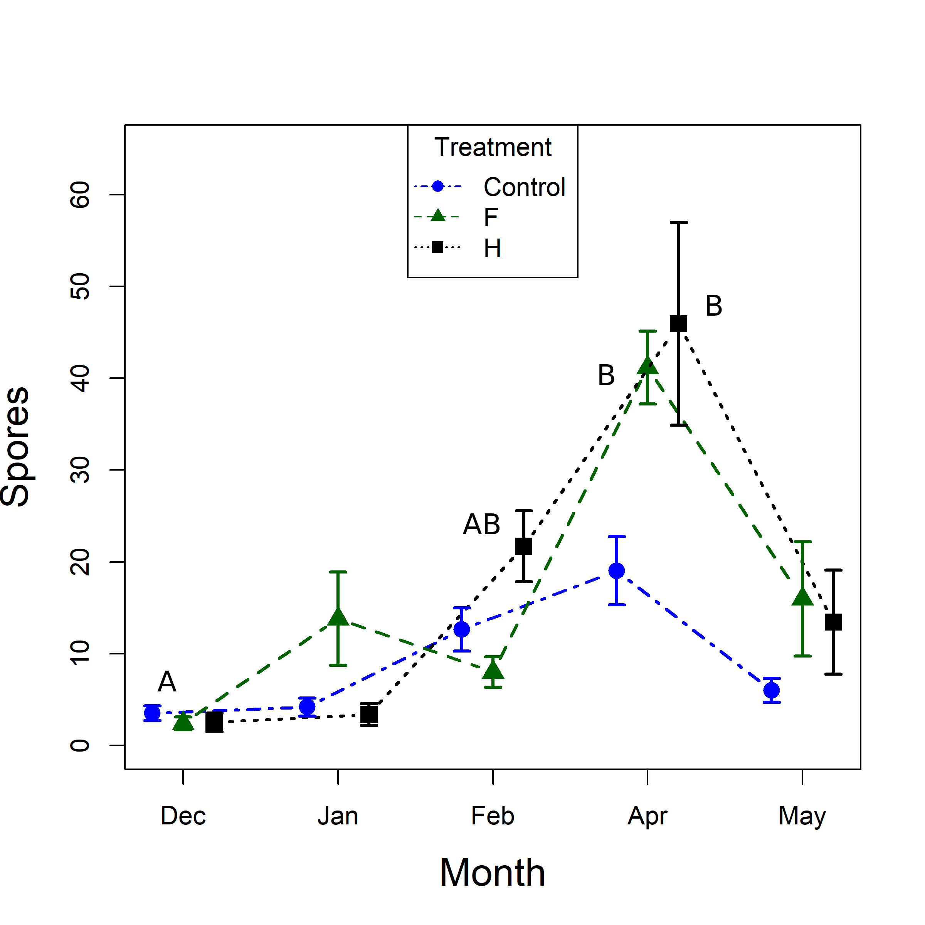

*Figure: Fumagilin-B*® *and Hive Alive*® *in April were significantly higher than all others.*

***Experiment 3: Winter Field Treatment using Fumagilin-B and Nosevit at Fall and Spring Recommended Treatments***

At the end of the experiment, colonies from the treatment groups did not differ significantly in the observed number of bees (F4,39 = 0.32, *p* = 0.866) or brood (F4,39 = 0.73, *p* = 0.58).

Across all treatments and observations, there was an average *Nosema* spore load of 608,247 spores per bee, with a prevalence of 0.83. The effect of the treatment on *Nosema* intensity was insignificant, but *Nosema* intensity was significantly affected by time (F3,194 = 24.39, *p* <0.001). The interaction between treatment and time did not significantly affect *Nosema* intensity. Similarly, *Nosema* prevalence was only significantly affected by the time variable (χ2 = 24.27, *p* <0.001).

***Experiment 4: Repeat of Winter Field Treatment using Fumagilin-B and Nosevit at Fall and Spring Recommended Treatments***

Overall, the number of observed bees and brood increased over time, but there was no effect from treatments. The effect of the treatment on the observed number of bees was insignificant, but the number of observed bees increased significantly over time (F1,93 = 125.05, *p* < 0.001). The interaction between treatment and time did not have a significant effect on the number of bees. Again, the amount of brood increased with time (F1,93 = 181.67, *p* < 0.001), but neither treatment nor the effect of the interaction between treatment and time had significant effects.

Across all treatments and observations, there was an average *Nosema* spore load of 673,500 spores per bee, with a prevalence of 0.80. The effect of treatment on *Nosema* intensity was insignificant, but *Nosema* intensity was significantly affected by time (F3,195 = 19.80, *p* < 0.001) and the interaction between treatment and time (F12,195 = 2.37, *p* = 0.009). Post-hoc analyses showed that only the Fumagilin-B fall treatment was significantly lower at the first week post application. For *Nosema* prevalence, the effect of treatment and the interaction between treatment and time was insignificant, but the effect of time was significant (χ2 = 26.17, *p* < 0.001).

**Discussion**